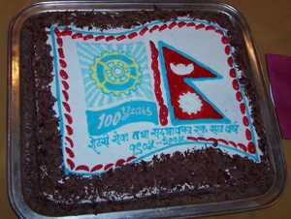
BREAKFAST CHATTER
Weekly Bulletin of Rotary Club of Kathmandu Mid-Town
District 3290 Volume No. 15/21 for #763 December 10, 2004
www.rotarymidtown.org.np
DECEMBER IS ELECTION OF NEW BOARD MONTH

SUNSHINE ANNOUNCEMENT FOR THE WEEK OF 10 DECEMBER 2004; Anniversary greetings this week to Lekha and Anand on Friday Itself, and to Shovana and Saroj on the 13th. And happy 100th to Rotary!!!. ***********
MEETING ACTIVITIES:
DATE | ACTIVITY | SUBJECT
10 DEC | Rabi Karmacharya | Software Outsourcing Prospects for Nepal
17 DEC | CLUB ASSEMBLY
24 DEC | HOLIDAY | HAPPY CHRISTMAS
31 DEC | speaker?? | OR?
7 JAN | Subarna Joshi | Community Participation in Local Area Development
JAN | Health Camps | Naubise & Tistung with ADRA/Hartmut
**************** NEWS:, Here is the latest winter schedule for English Medium RC:
Pashupati Wed 4:00 pm H. Everest Patan West Thu 4:30 pm H. Summit
Kantipur Thu 5:30 pm H. Ambassador Kasthamandap Fri 7:45 am Radisson
Kathmandu North Sun 4:30 pm Shangrila Kathmandu West Sun 8:30 am Grand H., Tahachal
Mt. Everest Sun 7:30 am H. Himalaya Metro Sun 6:00 pm at H. De L'Annapurna

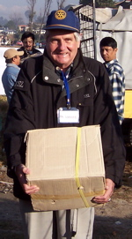
***
**************** THIS WEEK RABI KARMACHARYA WILL SHARE HIS VIEW OF NEPAL’S PROSPECTS FOR SOFT-WARE OUTSOURCING. A computer science & electrical engineering graduate of MIT, and a veteran of 3Com in Silicon Valley, Rabi co-founded Himalayan Techies in 2000. Today he manages the company’s daily operations, internal production as well and the important client interface. How likely is this to be a significant part of Nepal’s economy? ****************

Please join us! YIR…David

